Review on EEG Source Localization Algorithm based on 3D Grid Source Model

Qinyuan Wei

The core of the Localization problem is the inverse problem, which is known as the non-uniqueness of the inverse solution due to the lack of information. So many approaches can be addressed to this issue.

## Classical methods

1. MNE

MNE (minimum norm estimates) is a basic approach to solve this inverse problem. It can deal with the two-dimensional images and incapable of correct localization in 3D solution spaces. But it is the foundation of later methods.

2. LORETA

LORETA (low resolution brain electromagnetic tomography) is a method which can be used in source localization problems. It can provide the information about the depth but with a low resolution as it says in its name.

Basically, the approach of it to solve the inverse problem is to transfer the inverse problem into a minimum problem in a constrained solution.

3. sLORETA

sLORETA (Standardized low resolution brain electromagnetic tomography) is an improved method to solve source localization problems (compared to LORETA). It uses the standardized l2-norm, which achieves high accuracy and smooth but not sparse enough.

4. TV and gFOTV

TV (total variation) is a method with solve the problem in the transform-domain. It can achieve high accuracy and sparse. Based on the TV method, gFOTV uses fractional-order to enhance the step of total variation, which achieves a balance between sparse and smooth. Also, we can moderate the degree of sparse and smooth by adjust a parameter in the function.

## New methods

1. **LCMV**

**Papers:**

* **Localization of Brain Electrical Activity via Linearly Constrained Minimum Variance Spatial Filtering**
* **Source Localization of Event-Related Potentials Incorporating Spatial Notch Filters**
  1. Basic Info

LCMV (Linearly Constrained Minimum Variance) is a beamforming method, which is a classical spatial filtering method in signal localization. Unlike minimum norm method, it does not need the procedure of regularization.

* 1. Head Model

In the paper, the authors use a three layer spherical head model with conductivities of 0.33, 0.0042, 0.33 μS/cm, for scalp, skull, and brain, respectively.

* 1. Algorithm and Objective Function

LCMV does not need to solve the minimum norm question, so it does not need to have an objective function.

The algorithm of LCMV is :

We have the model of EEG signal : , b is the signal vector of sensors, A is the lead field, u is the source current density and n is the noise.

Our goal is to find a matrix W to minimize the variance of

So we can use Laplacian operator to acquire the W and u.

* 1. Evaluation

1. **MCE**

**Papers:**

* **Visualization of Magnetoencephalographic Data Using Minimum Current Estimates**
  1. Basic Info

MCE (Minimum Current Estimates) is a method based on the MNE, which is raised in 1999. It minimizes the sum of the absolute currents (l-1 norm).

* 1. Head Model

In the article, the author uses a triangle mesh spherically symmetric head model.

* 1. Algorithm and Objective Function

The objective function is:

S.T.

The whole algorithm consists following steps:

1. Find the minimum weighted l2-norm estimate u0 by minimizing the function above.
2. Create the orientation matrix in which each row is a vector describing the current orientation in u0 in the corresponding location. Scale the vectors to Euclidean norm one.
3. Find the weighted minimum l 1-norm estimate by minimizing:

, **t** is the source strength vector,

S.T.

* 1. Evaluation

In the paper, the author uses MCE on MEG data, which is collected from a stimulus test on real human. However, maybe due to the date of this paper, instead of using data to evaluate, the author uses two examples to illustrate the advantage of this method, which is good at finding the actual distribution when the true sources are focal.

1. **cMEM**

**Papers:**

* **Localization Accuracy of Distributed Inverse Solutions for Electric and Magnetic Source Imaging of Interictal Epileptic Discharges in Patients with Focal Epilepsy**
  1. Basic Info

cMEM (coherent Maximum Entropy on the Mean, 2013) is an improvement of MEM method. The MEM solver relies on a probabilistic (Bayesian) approach where inference on the current source intensities is estimated from the informational content in the data (notion of maximum of entropy).

* 1. Head Model

In this article, the author uses realistic simulations of simultaneous EEG signal, which have 257 sensors, involving a biophysical computational neural mass model of neuronal discharges and realistically shaped head models. The spatially extended source was made of contiguous triangles manually outlined using a mesh visualization software.

The distributed source space consisted in a mesh (8000 vertices) of the cortical surface that was obtained by segmenting the grey-white matter interface from a subject's anatomical MRI using BrainVISA-4.2.1 software2 (Mangin etal.,1995). Using the OpenMEEG (Gramfort et al., 2011) implementation in Brainstorm software (Tadeletal., 2011), they generated a 3-layer EEG Boundary Element Method (BEM) model consisting of the inner skull, outer skull and the scalp surfaces, with corresponding conductivity values of 0.33:0.0165:0.33S/m respectively (Ferreeetal.,2000; Hoekema et al.,2003; Lai etal.,2005).

* 1. Algorithm and Optimization function

To the best of my knowledge, cMEM is a method trying to maximize the entropy, which can be calculated from known information, by adjusting the parameters. After the entropy is maximized, we can calculate the source location.

MEM approach is now available for users as a toolbox (namely, BEst: Brain Entropy in space and time) in the Brainstorm software and the tutorial introducing this toolbox can be downloaded.

* 1. Evaluation

In the article, the author uses several evaluation criteria: Signal-to-Noise Ratio (SNR), Cancellation index (Ic), Area Under the Receiver Operating Characteristic (ROC) Curve, AUC, Spatial Dispersion (SD), Shape error (SE). In the EEG test, when the source is basal temporal, AUC=0.83, SD=28, SE=0.18; when the source is SMA, AUC=0.88, SD=36, SE=0.26.

Another article (Localization Accuracy of Distributed Inverse Solutions for Electric and Magnetic Source Imaging of Interictal Epileptic Discharges in Patients with Focal Epilepsy) suggests that cMEM is better than MNE and LORETA, which is more sparse and accurate.

1. **VW-SSI**

**Papers:**

* **Reconstructing spatially extended brain sources via enforcing multiple transform sparseness**
  1. Basic Info

VW-SSI (variation and wavelet based sparse source imaging, 2013) is a method based on l1-norm regularization with the enforcement of transform sparseness in both variation and wavelet domains.

* 1. Head Model

An averaged structural MRI from FreeSurfer (http://surfer.nmr.mgh.harvard.edu) was used to build the CCD model and head volume conductor model for simulations. The cortical surface was segmented at the interface of gray and white matters and tessellated into 40,960 triangles with each of 3.23 ± 1.14 mm2 (mean ± SD) using FreeSurfer (Dale et al., 1999).

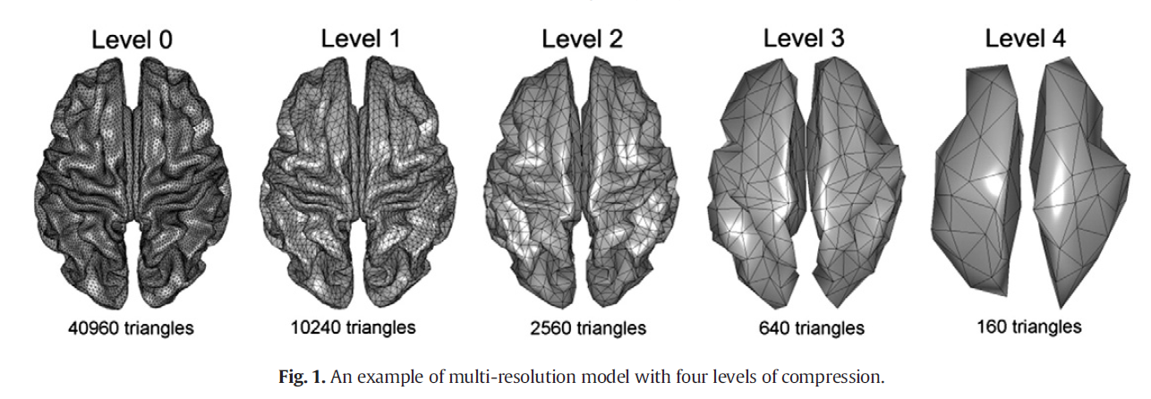

* 1. Algorithm and Optimization Function

VW-SSI combines the variation and wavelet penalties.

The physical function is:

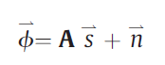

n denotes the noise and A is the lead field.

And the optimization function is:

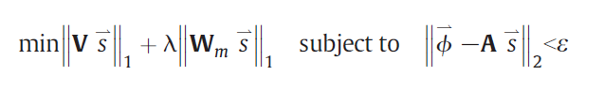

V is the variation vector used in variation transform. is the wavelet transform matrix. is the hyper-parameter to balance variation and wavelet penalties.

* 1. Evaluation

In the article, the author uses MEG data to evaluate VW-SSI.

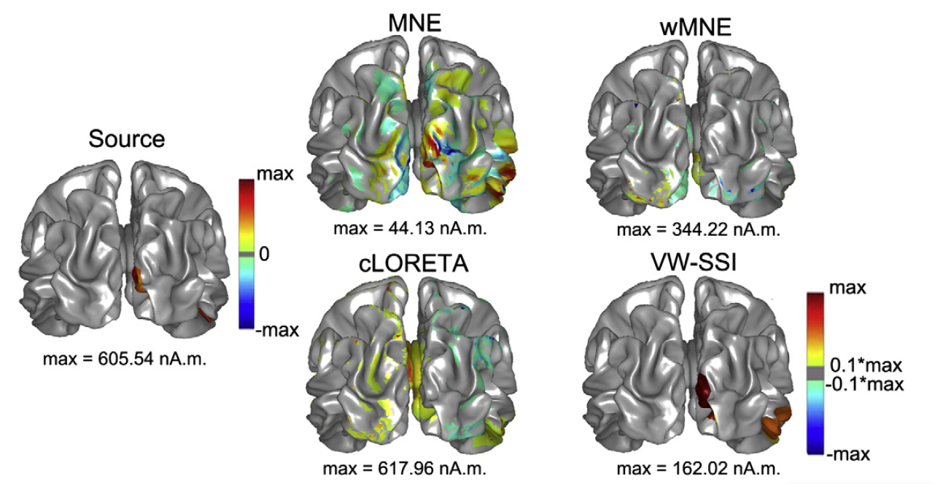

1. **STOUT**

**Papers:**

* **Solving the EEG inverse problem based on space–time–frequency structured sparsity constraints**
  1. Basic Info

STOUT (spatio-temporal unifying tomography, 2015) is a method combines the strength of two existing methods, namely Sparse Basis Field Expansions (Haufe et al., 2011) and Time–Frequency Mixed-Norm Estimates (Gramfort et al., 2013).

* 1. Head Model

An average head model.

The author provides all his data on github.

* 1. Algorithm and Optimization Function

This algorithm is a combination of S-FLEX, which is a sparse one, and TF-MxNE, which is a smooth one. It has the features of these two methods. And by using a parameter, we can control the performance of STOUT by more sparse or more smooth.

* 1. Evaluation

The author in the article provide several figures to illustrate the advantage of this method.

First, he compares the time-space resolution of different methods:

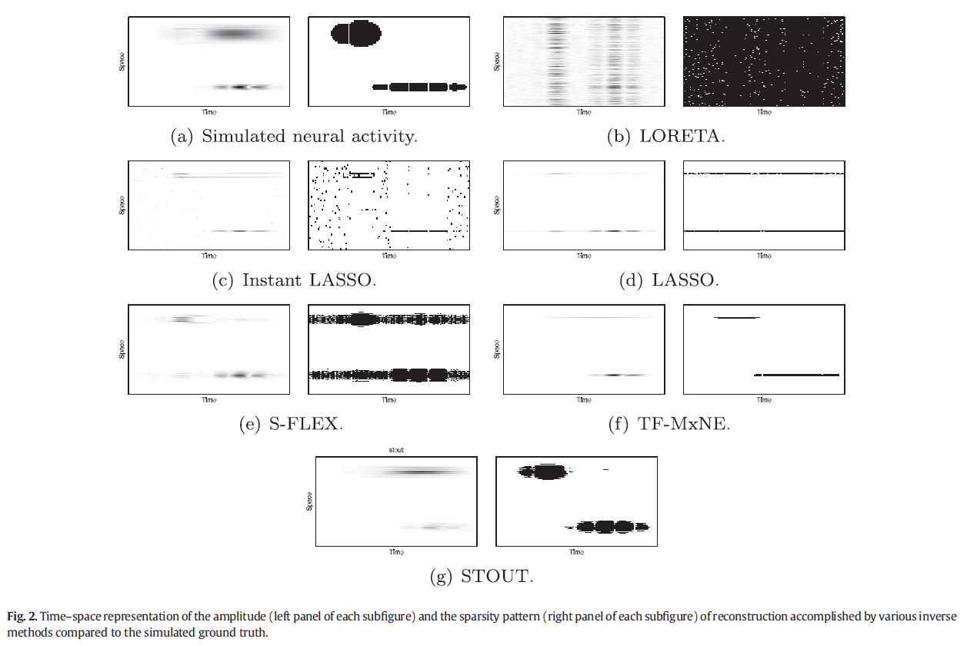

Then he compares the reconstruction accuracy of different methods:

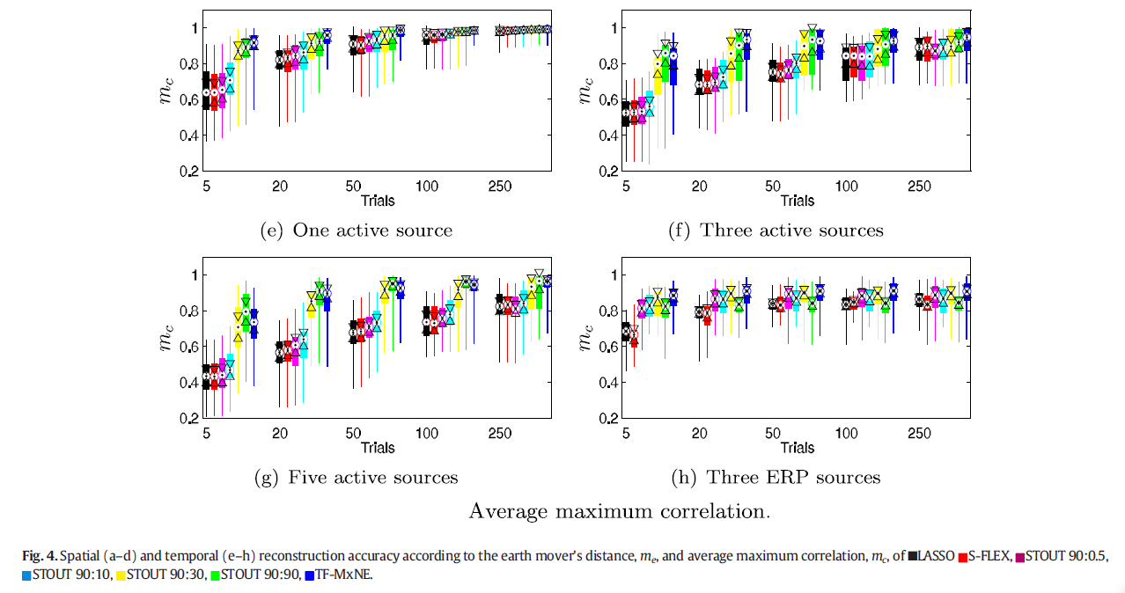

1. **IRES**

**Papers:**

* **Imaging brain source extent from EEG/MEG by means of an iteratively reweighted edge sparsity minimization (IRES) strategy**
  1. Basic Info

IRES (iteratively reweighted edge sparsity minimization, 2016) is a method, which uses an iterative reweighting strategy to penalize locations that are less likely to contain any source.

* 1. Head Model

The author uses a realistic cortex model, which is derived from MR images of a human subject. The forward model is more elaborate and has a higher spatial resolution than the inverse model, both of which are triangle meshed.

The author also uses real data to test IRES.

* 1. Algorithm and Optimization Function

The basic idea of this method is using iterative function to calculate the l1-norm convex optimization problem derived from the data.

* 1. Evaluation

The author uses 3 metrics to evaluate the performance of IRES: localization error (LE), normalized overlap ratio (NOR) and the area under curve (AUC) analysis. The result is shown in the picture below.

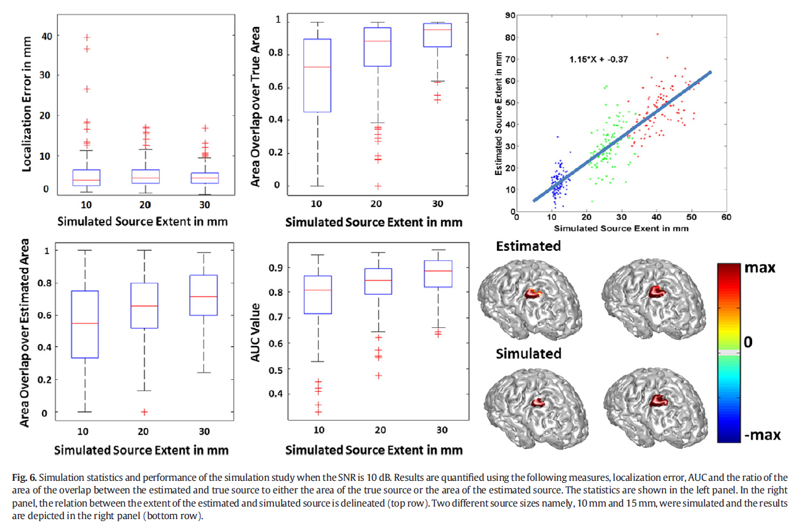

1. **Hierarchical Bayesian Modeling (HBM) Methods**

**Papers:**

* **Lucka F, Pursiainen S, Burger M, et al. Hierarchical Bayesian inference for the EEG inverse problem using realistic FE head models: depth localization and source separation for focal primary currents[J]. Neuroimage, 2012, 61(4):1364-1382.**
* **Lucka F. Hierarchical Bayesian Approaches to the Inverse Problem of EEG/MEG Current Density Reconstruction[J]. 2011.**
  1. Basic Info

Hierarchical Bayesian methods based on Bayesian modeling to solve the inverse problem. Instead of using fixed regularization functions to calculate, the regularization functions used by these methods based on the measured data, which is the key to its outstanding performance. Also, these approaches have good results in 3D model.

* 1. Head Model

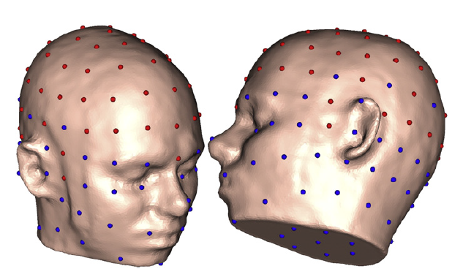

* 1. Source Model

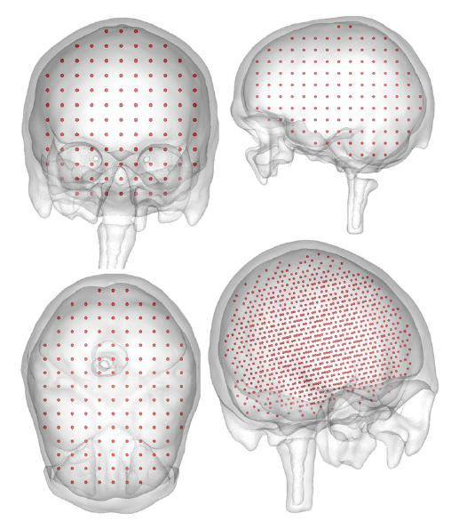

* 1. Results and Evaluation

Showed in the papers.

Also in this paper, the authors mentions that no regularization methods can have good results in the 3D model. But he does not tell the reason. So the Bayesian methods may be the only mathematical way to solve the inverse problem in 3D model.

And I find a slides in which it talks about the mathematical explanation of the inaccuracy of regularization methods. (see ‘ParisTelecom_03_03_2016.pdf’)